<https://www.youtube.com/watch?v=Q33KBiDriJY>

HTML is the standard markup language for creating Web Pages. It stands for Hyper Text Markup Language and describes the structure of Web pages using markup.

It constitutes of **elements** and these elements are the building blocks of any HTML page and are represented by **tags**.

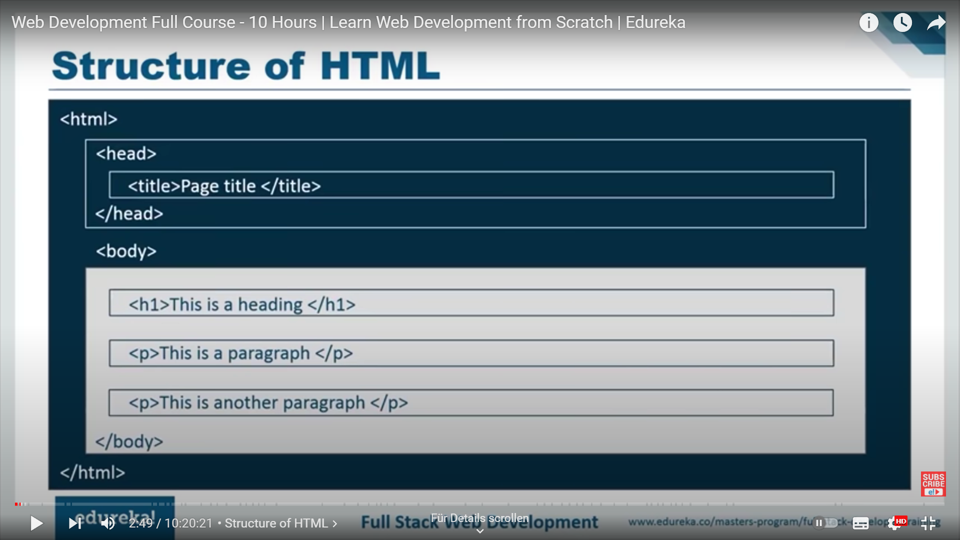

HTML structure AKA Boilerplate

The HTML page start with the <html> tag, telling the browser this is an HTML page.

The <head> tag contains the meta information about the document (link to the styling sheet, the fonts, the javascript code”. Internal to the <head> tag there is a <title> tag that contains the title that will be displayed on the browser tab.

The <body> tag contains the content visible to the viewer. Mainly contains <h1> and <p> tags.

The <!DOCTYPE> element is a declaration that represents the document type it helps the browesers to display web pages correctly.

A web page is made of three constitutes: HTML, CSS and Javascript.

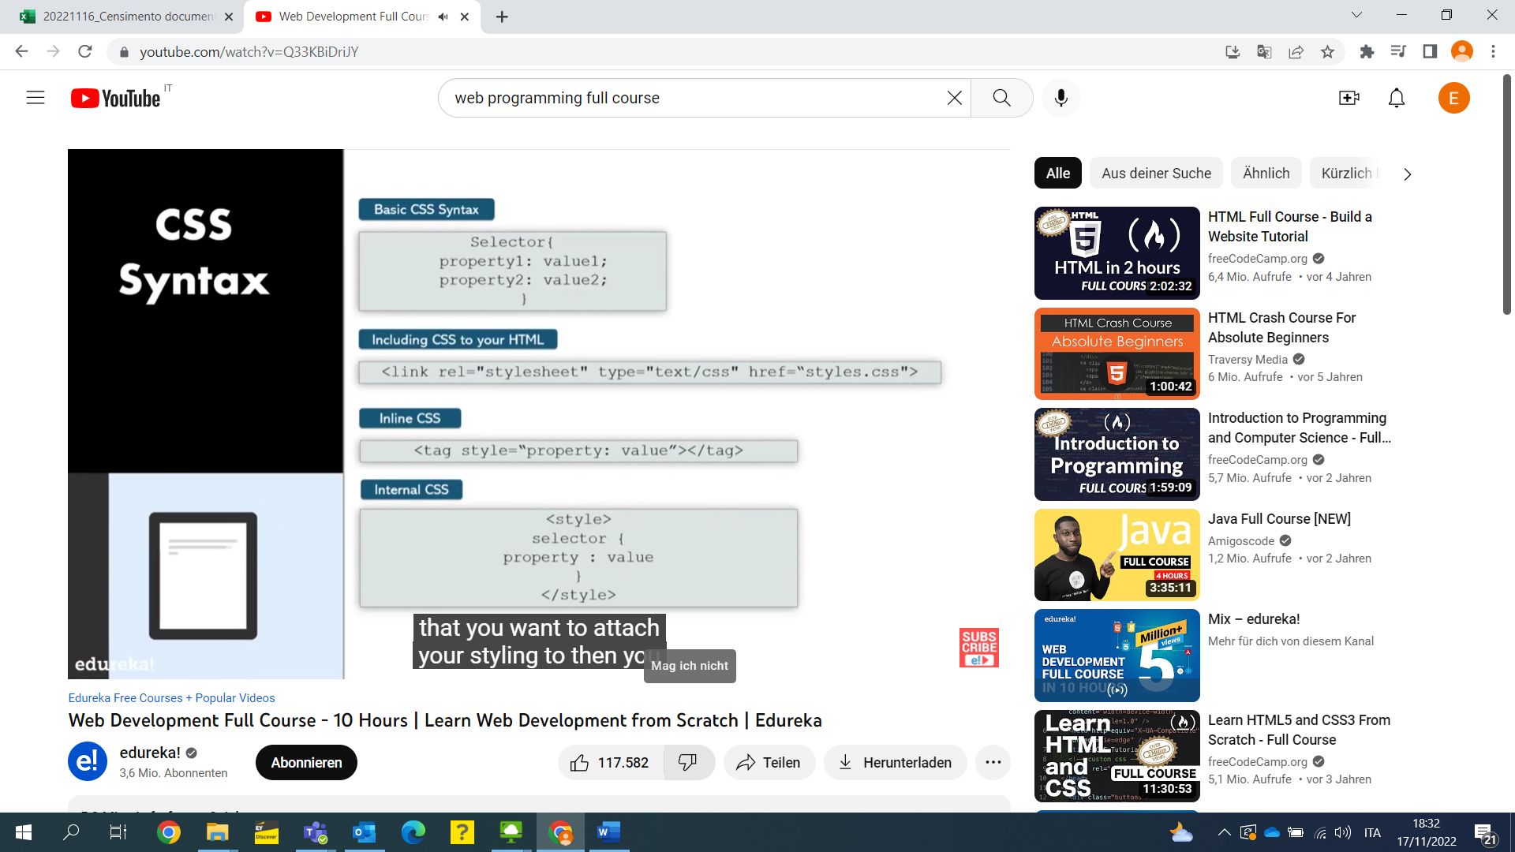

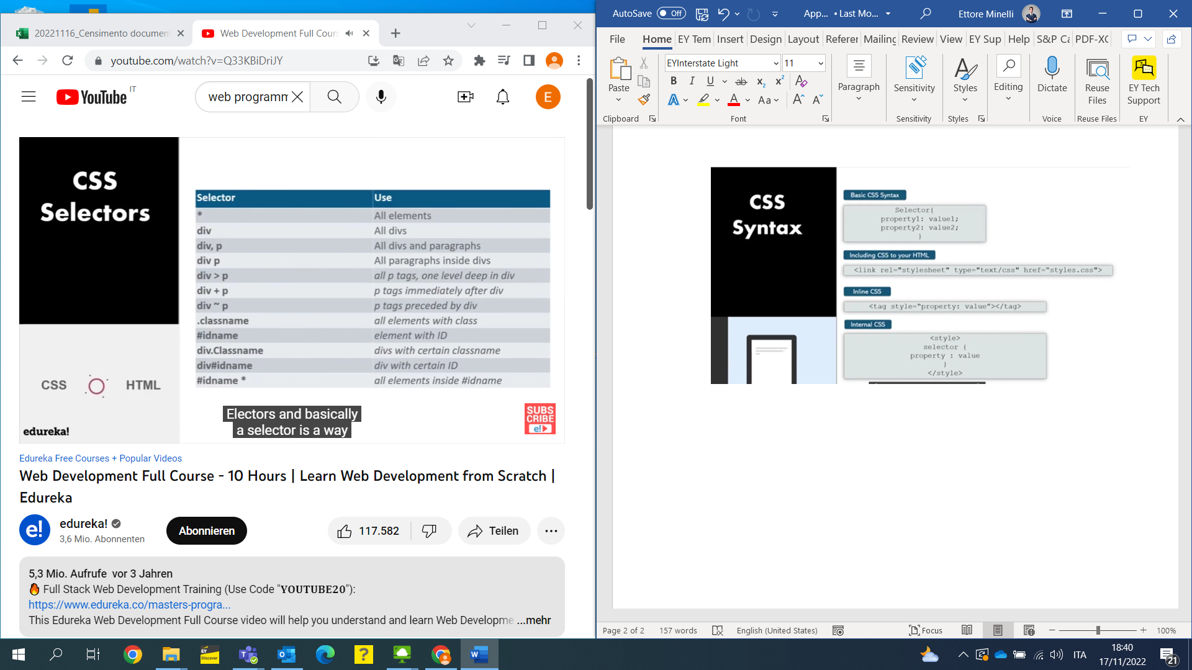

<https://www.w3schools.com/csSref/css_selectors.php>

